**Mr. Visca’s: Calculus (sec 7.3 part 2)**

**Chpt 7 – Day 5 - part 2: Volume by Disks, Washers and Shells**

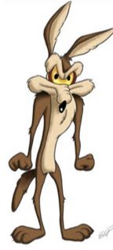

My boss at the ACME Rocket Company has assigned me to build a nose cone in this shape.

Suppose I start with this curve...so I put a piece of wood in a lathe and turn it to a shape to

match the curve below:

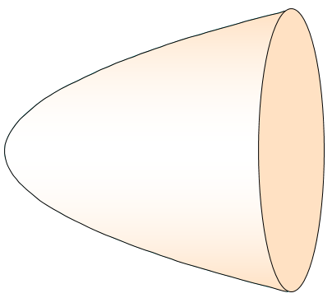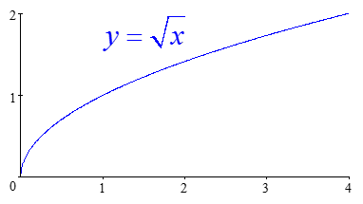

How could we find the volume of the cone?

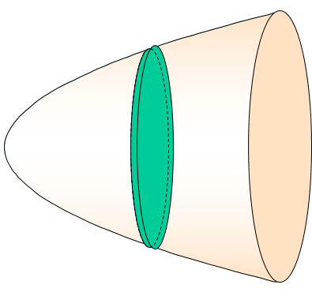One way would be to cut it into a series of thin slices (flat cylinders) and add their volumes (integrals).

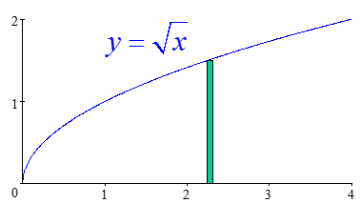

Vcylinder = _____________________

* h = height, same thing as *thickness,* our small change in thickness, x, for our cylinders is represented as *dx*
* radius = y value (our function)

Therefore, to add up all our cylinders under the curve, we use:

Vshape = ________________________________

If the shape is rotated about the x-axis, then the formula is: _________________

If the shape is rotated about the y-axis, then the formula is: _________________

This is called the ____________ method.

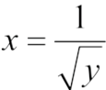

The region between the curve , 1 ≤ y ≤ 4 and the *y*-axis is revolved about the *y*-axis. Find the volume.

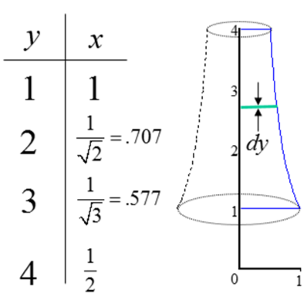

This is a horizontal disk, the thickness of the disk is, *________________*

The radius is x; __________________________

Therefore, V = _______________________________

The natural draft cooling tower shown at left is about 500 feet high and its shape can be approximated by the graph of this equation revolved about the y-axis:

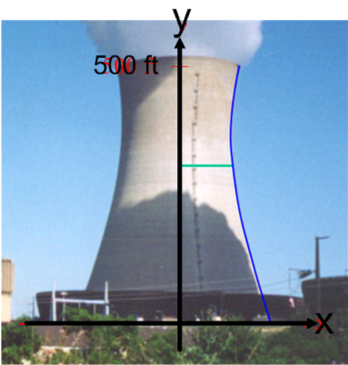 x = .000574y2 - .439y + 185

Set up the integration to solve for volume. Then solve (use calculator)

The region bounded by y = x2 and y = 2x is revolved about the y-axis. Find the volume.

If we use a horizontal slice: The “disk” now has a hole in it, making it a ___________________

Draw the solid and slice, then set up volume integral.

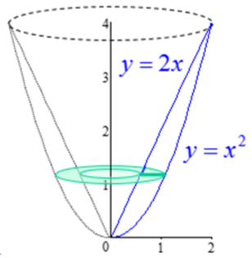

This application of the method of slicing is called the ________________________________. The shape of the slice is a circle with a hole in it, so we subtract the area of the inner circle from the area of the outer circle.

V =_____________________________

If the same region from the previous problem is rotated about the line *x* = *2,* we still this volume, however,

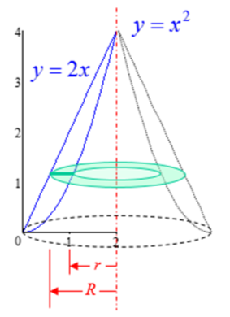

The outer radius is:

The inner radius is:

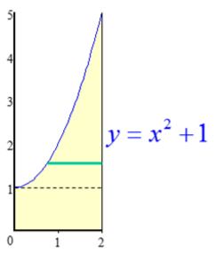Solve for the volume made by the shape as it is revolved around the y axis.

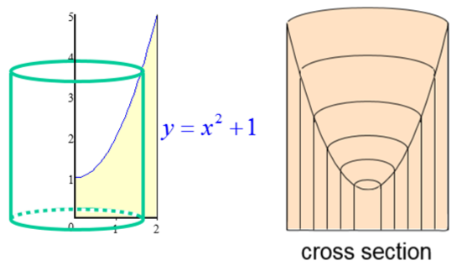

Here is another way we could approach this problem:

If we take a vertical slice and revolve it around the

y-axis, we get a cylinder.

The volume of a thin, hollow cylinder is given by:

* Lateral surface area * thickness
* circumference * height * thickness
* (2πr)(h)(thickness)

We call this the _____________________

If we add all the cylinders from the smallest to the largest: V =

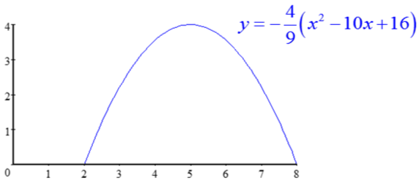Find the volume generated when this shape is revolved about the y axis.

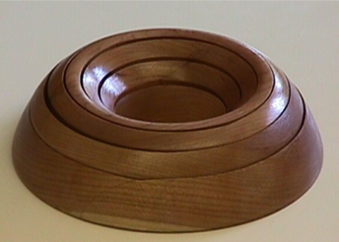

We can’t solve for x, so we can’t use a _______________________________ directly.

If we take a vertical slice, and revolve it around the y-axis, we get a _____________________________

Volume of thin cylinder: ______________________________

Volume of our shape: __________________________________ (put in calculator, carefully!)

So, the million dollar question is...

**Washer** **Shell**

when your shape resembles a when your shape resembles a

________________________. ________________________.

**Homework Section 7.3:**

#s 7,8,10,11,14,17,24,27,28